CubeSat Planar Turnstile UHF Antenna

James Allen Morrison

Rice University

20 March 2022

The OWLSAT team designed a 4-element planar turnstile antenna based on the Oresat canted turnstile design. The original design is derived from a NASA technical document on the design of miniaturized satellite antennas. The antenna is designed for a center frequency of 435 MHz in the UHF band with a 50 ohm coax-fed feed circuit, three Mini-circuits QBA-07+ 90 degree hybrid couplers, and then four $λ$/4 monopoles made out of stainless-steel measuring tape.

Figure 1. Schematic and line lengths

The feed circuit operates by creating 4 antenna feeds that are successively 90 degrees apart. This is accomplished by splitting the radio input by 0 and 90 degrees, then shifting the 90 degrees path by an additional 90 degrees via a co-planar waveguide (CPWG). From there the 0 and 180-degree paths are split again, which produces a 0, 90, 180, and 270 degree output to each element, respectively. The derivation for the delay line lengths is detailed in figure 2, which are based on an FR4 thickness of 62 mils and a 50 ohm CPWG calculation for propagation delay in Altium Designer (PCB design software). From this, the propagation velocity can be found from the inverse of propagation delay, which leads to the direct theoretical values for “perfectly electrically conductive” elements as well as a very accurate estimate of the delay line lengths since the Altium simulation takes into many of the parasitics aspects. Note that the schematic includes extra components such as the right-angled MMCX jack to accommodate future assembly issues if a straight jack is no longer suitable.

Figure 2. Derivation of Element Length and Delay Lines

A final simulation in HFSS pictured in figure 4 confirmed that a much shorter element length of 132 mm is more realistic assuming the feed circuit is perfect and lossless. The expected slightly directed omni-directional pattern is cross-confirmed with MATLAB in figure 3 at a peak directivity of 2.2 dBi.

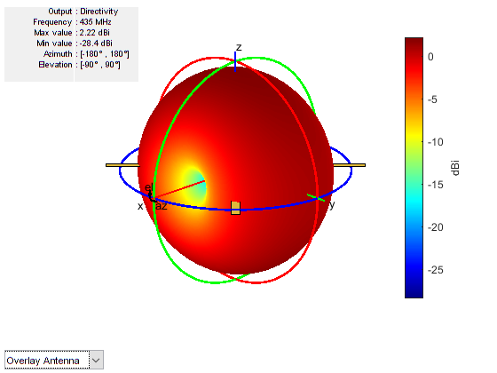

Figure 3. MATLAB Simulation

Figure 4. HFSS Radiation Pattern with Spacecraft Model

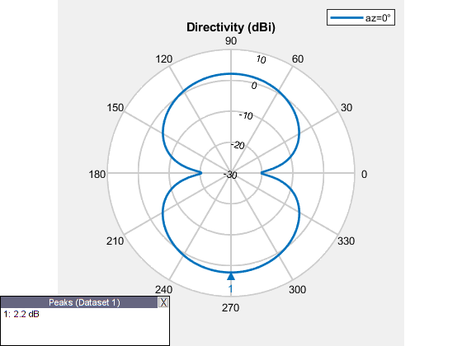

Figure 5. Simulated Elevation Pattern

**Testing**

The board files had a mistake such that 4 circles were accidentally place on the mechanical layer of the board and were interpreted by the automated fabrication process through Advanced Circuits to be non-plated through holes (except for one hole that is plated!). Thankfully, this simply adds to the flexibility of the mounting options, but could have been disastrous. The cause of the circles is unclear at this time.